Title of the Article (Franklin Gothic Demi Cond, 16pt, left aligned, Line spacing 1.15)
Author’s first Name A. Last Name ^{a*}, Author’s first Name B. Last Name ^{b} (Cambria, 11pt, left aligned, space 1pt)
Affiliations ^{a, b} University name, city name, region if present, country name. (Cambria, 9Pt, Italic, space 1.15pt)
Affiliations ^{b} University name, city name, region if present, country name. (Cambria, 9Pt, Italic, space 1.15pt)

*Corresponding Author’s Email address (ex., authors.authors@example.com) (Cambria, 10Pt)
Corresponding Author’s ORCID# (0000-0000-0000-0000) sixteen digits/ hyperlinked to author’s name (Cambria, 10Pt)

ABSTRACT (Cambria, 12pt, Bold)
Abstract’s body text (Note/ only 250 words is acceptable) (Cambria, 10pt, spacing line 1.15pt)
About 250 words of the effective words need to present the author’s work. Abstract should be informative and deals with what the authors used in their methodology and presenting results as well as a final conclusion of what they achieved in their works in one paragraph only.

Keywords: submit at least 5 keywords, use comma (,) between them. (Cambria, 9pt)

- Introduction (Franklin Gothic Demi Cond, 12pt)
In the Introduction section, the authors should introduce their works and their location of the study as well as the literature review of the present work and connecting to what the other authors achieved in the same circumstances (Adam, 2025). (Cambria, 11pt, spacing line 1.15, Indentation at first line with 0.5 cm (0.2inch))
The authors should care about using newest references and show a brief definition to their work with comparison with the other works. Each paragraph in the introduction should have own indentation with the first line and with 0.5 cm (Adam & Lisa, 2024).
  - Literature Review (Franklin Gothic Demi Cond, 10pt)
Using recent literature (ideally from the last 5 years) is essential for demonstrating that your manuscript is current, reducing the risk of rejection by showing awareness of the latest developments. Citing only your own previous work suggests a narrow, outdated literature base. Only include the best, most relevant sources rather than a high volume of citations (Adam et al, 2023; Adam & Lisa, 2024; Adam, 2025).
  - Geology of the area (Franklin Gothic Demi Cond, 10pt)
Some disciplines may include specific information in the introductory subsections. Thus, to avoid a crowdy introduction it’s allowed to divide the introduction section into subsections like geology of the area (Fig. 1).
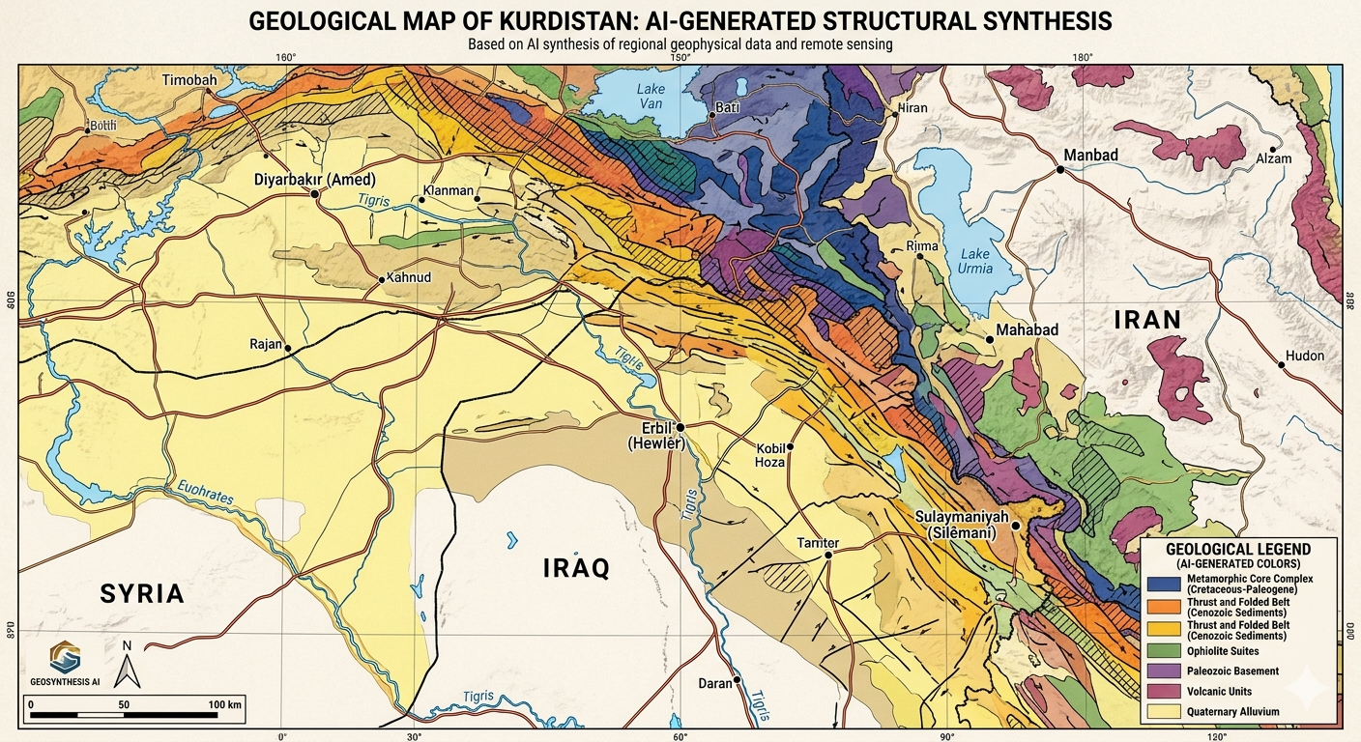
Figure 1. Geological Map of Kurdistan (AI-Generated).

Figure captions (Cambria, 9pt, single line spacing) Figure captions should be under figures or photos.
Arial-Narrow fonts are recommended for labeling on the figures.
Figure formats are like Eps. Ai. Svg. Jpg. Emf. are accepted. Figure fonts like Arial-Narrow are required.
Figure size and resolutions for single columns (width 8.5c m X height 9-10cm) 300 ppi.
Figure size and resolutions for full page in Manuscript (width 15cm X height 10cm) or (width 17cm X height 10-13cm) 300 ppi.
Table captions (Cambria, 9pt, single line spacing) Table captions should be above tables
Submit tables as word tables or as emf tables. (Table content font of Garamond 8-10 pt. is accepted).
Table size for single columns (width 8.5cm X height 5-10cm)
Table size for full page in Manuscript (width 17cm X height 10-21cm)

- Materials and Methods or Methodology (Franklin Gothic Demi Cond, 12pt)
In this section, select the suitable section name for your article, like materials and methods or Methodology. As well as organizing the section using subheadings to create a chronological or thematic flow (see subsections below). Better to start with a high-level summary of the approach (e.g., qualitative, quantitative, mixed-methods, experimental) and its rationale. Each paragraph in the methodology should have own indentation with the first line and with 0.5 cm. Regarding Participants and/or Subjects, describe who or what was studied, including selection criteria (inclusion/exclusion) and sampling methods. Consider identifying all tools, equipment, software, or reagents used, including manufacturer details (e.g., Name, City, Country). Also provide a step-by-step, chronological account of how data were generated or gathered. Don’t forget to write in detail about the techniques used to process data, including statistical tests and software packages used. Finally, document approval (Ethical Form) from an ethics committee, and mention informed consent procedures are highly required for Bio articles.

  - Methodology 1 ex. (XRD analysis) (Franklin Gothic Demi Cond, 10pt)

  - Methodology 2 ex. (statistical analysis) (Franklin Gothic Demi Cond, 10pt)

  - Methodology 3 ex. (chemicals) (Franklin Gothic Demi Cond, 10pt)

  - Methodology 4 ex. (blood sampling) (Franklin Gothic Demi Cond, 10pt)
The authors better use the past tense to describe what was already completed. The journal does not recommend direct active voice ("We measured"), but passive voice ("Measurements were taken") or (the authors measured) are highly recommended. Don’t forget to utilize flowcharts, diagrams, or tables for complex procedures to improve readability (Fig. 2a & b). Do not omit sample sizes, precise measurements, or specific software versions (Fig. 2a-c). And never discuss or interpret results in the methodology section as shown in Figure 2.

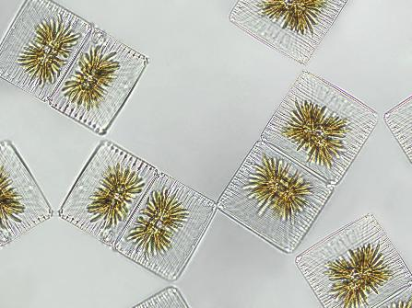
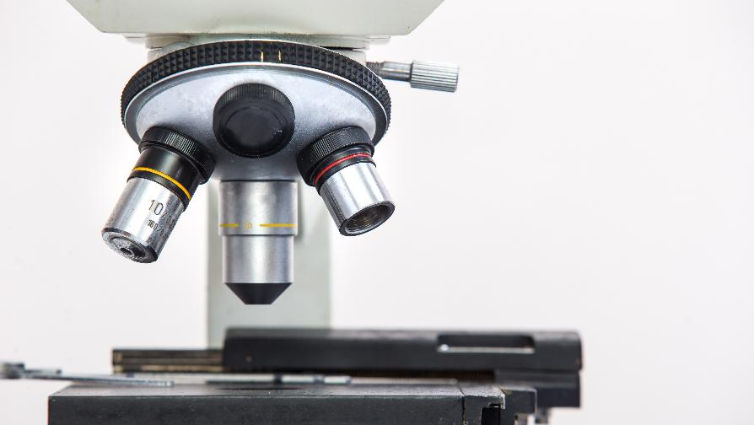
A
B
C

Figure 2. Parts of Microscope and its applications (a) Thin section under microscope 10X objective used, (b) Algae example, and (c) Front view of the Microscope.
- Results (Franklin Gothic Demi Cond, 12pt)
The results section of a research paper is the core of your article, presenting key findings objectively without interpretation. It should tell the "story" of your findings in a clear, concise, and logical sequence (Table 1). You can use subheadings or subsections to break up findings by experiment, theme, or topic, making the result section easy to navigate. Never discuss or explain the results (save this for the Discussion section). Thus, state only what was found, not what the findings mean as shown in Table 1. Each paragraph in the results should have own indentation with the first line and with 0.5 cm.

  - Result 1 (Franklin Gothic Demi Cond, 10pt)

  - Result 2 (Franklin Gothic Demi Cond, 10pt)

Example for Tables and table captions
Table 1. This table deals with the data related to the rain precipitations (in millimeters) among years 2000-2006.
 | 2000 | 2001 | 2002 | 2003 | 2004 | 2005 | 2006
September | 15 mm | 5 mm* | 5 mm | 15 mm | 5 mm* | 5 mm | 15 mm
October | 25 mm | 20 mm | 21 mm | 25 mm | 20 mm | 21 mm | 25 mm
November | 120 mm | 100 mm | 110 mm | 120 mm | 100 mm | 110 mm | 120 mm
December | 200 mm | 150 mm | 151 mm | 200 mm | 150 mm | 151 mm | 200 mm
January | 250 mm | 210 mm | 220 mm | 250 mm | 210 mm | 220 mm | 250 mm
February | 130 mm | 180 mm | 130 mm | 130 mm | 180 mm | 130 mm | 130 mm
March | 54 mm | 59 mm | 50 mm | 54 mm | 59 mm | 50 mm | 54 mm
April | 68 mm | 34 mm | 44 mm | 68 mm | 34 mm | 44 mm | 68 mm
May | 45 mm | 40 mm | 42 mm* | 45 mm | 40 mm | 42 mm* | 45 mm
* Uncertain records

- Discussions (Franklin Gothic Demi Cond, 12pt)
Discussion section interprets the results, contextualizes them within existing literature, and explains their significance (Figs. 1 & 2). Explain the findings' significance. What do they mean? How do they support or refute your initial hypothesis?
It is better to compare and contrast your results with previous studies. Discuss why your findings align with, differ from, or extend existing literature. Use present tense for established facts and to discuss the study findings. Keep paragraphs focused (100–200 words) and avoid overly long explanations. Best discussions always offer concrete suggestions for future research. Each paragraph in the discussions should have own indentation with the first line and with 0.5 cm.
4.1 Discussion 1 (Franklin Gothic Demi Cond, 10pt)
4.1 Discussion 2 (Franklin Gothic Demi Cond, 10pt)
- Conclusions (Franklin Gothic Demi Cond, 12pt)
A conclusion is usually only one or two paragraphs (150–300 words), but you can use numbering method with letters (a, b, c, d) alignments.
- The conclusions …….
- The conclusions …….
- The conclusions ……

Fund (Franklin Gothic Demi Cond, 12pt, spacing 1.15pt)
If available (Cambria, 11pt, spacing line 1.15, Indentation at first line with 0.5 cm)

Conflict of interest (Franklin Gothic Demi Cond, 12pt, spacing 1.15pt)
The author declares that there are no conflicts of interest pertaining to this manuscript. (Cambria, 11pt, spacing line 1.15, Indentation at first line with 0.5 cm)

CRediT authorship contribution statement (Franklin Gothic Demi Cond, 12pt, spacing 1.15pt)
This is very important and states what the author’s performed in their entire research (Cambria, 11pt, spacing line 1.15, Indentation at first line with 0.5 cm)

Acknowledgments (Franklin Gothic Demi Cond, 12pt, spacing 1.15pt)
The author expresses his gratitude (Cambria, 11pt, spacing line 1.15, Indentation at first line with 0.5 cm)

References
References body text examples (Pearce, 1996; Wang et al., 2016; Ahmad & Pearce, 2022), numbering style is not accepted. Provide DOI for all references as much as possible.
References list or bibliography (Cambria, 10pt, spacing line 1.15, Indentation Hanging with 0.5 cm) Examples...

Ex,.
Research Articles…
Gorbach, N. V., Portnyagin, M. V., Ovsyannikov, G. N., Nyzhdaev, I. A., Philosofova, T. M., & Plechova, A. A., (2025): First Data on Lamprophyre-Like, Amphibole-Rich Basaltic Andesites Erupted in 2024 on the Western Slope of Shiveluch Volcanic Massif, Kamchatka. Journal of Volcanology and Seismology, 19(Suppl 1), S44-S54. https://doi.org/10.1134/S0742046325700587
Wang, T., Wang, Z., Yan, Z., Ma, Z., He, S., Fu, C., and Wang, D., (2016): Geochronological and geochemical evidence of amphibolite from the Hualong Group, Northwest China: Implication for the early Paleozoic accretionary tectonics of the Central Qilian belt. Lithos, 248, pp.12-21. https://doi.org/10.1016/j.lithos.2016.01.012

Books...
Hibbard, M.J., (1995): Petrography to Petrogenesis. Prentice Hall. Macmillan College, London. 720p.

Book Chapter…
White, M.J., (1995): Magmatic history through Petrography. In Hibbard, M.J., (Ed), Petrography to Petrogenesis (pp. 380-396). Prentice Hall. Macmillan College, London. DOI………

MSc and PhD Thesis (published Thesis is recommended) …
Qaradaghi, M.A. J., (2024): Genesis and Tectonics of Basaltic Pillow Lava and Peperites within Walash Volcano-sedimentary group, Mawat Area, Iraqi Kurdistan Region. Published PhD Thesis, University of Sulaimani. 208p.

